How to setup the Project:

1. Install JavaFX and scene builder:

<https://gluonhq.com/products/scene-builder/> --> Note the location of your download.

<https://gluonhq.com/products/javafx/> --> Choose to download SDK and note the location of your download.

1. Add a run configuration like this, but modify the path in the VM options to your JavaFX lib folder (you must add a VM option first from “Modify options”):

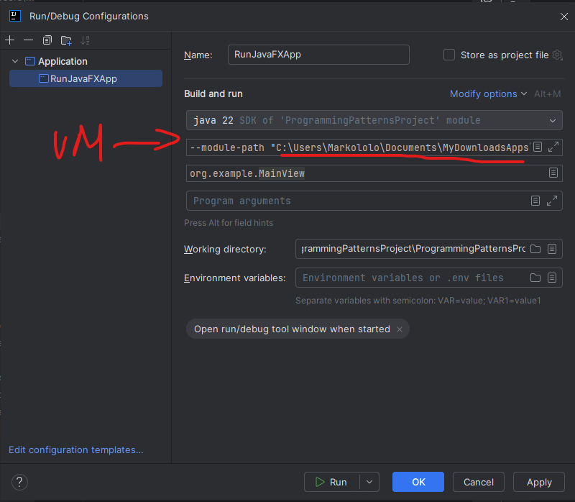

1. Add JavaFX libraries (all the .jar in your JavaFX lib folder):

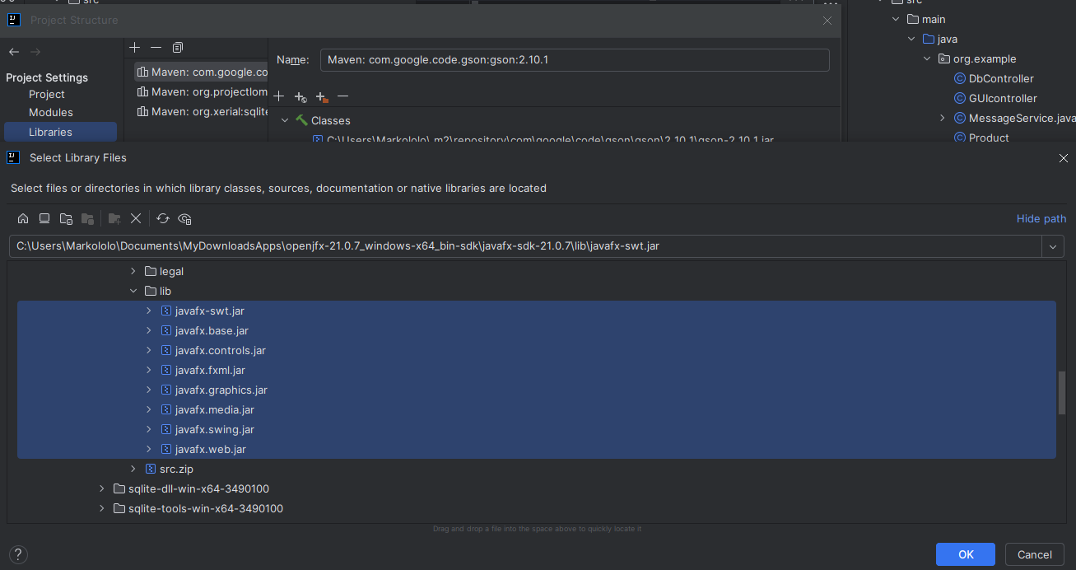

1. Connect to your scene builder (path to your .exe)

